Lesson plan

Unit 13 | Lesson: 37 | My home …

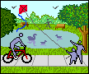
Date:
‏‏Class: 6th form
Date:
Class: 6th form
Objectives:
By the end of this lesson pupils should be able to:
- Naming and locating town amenities
New language:
Vocabulary : Supermarket – bank – restaurant –park – police station – cinema
Structures: Prep of location: on the right/on the left/between/next to
Pronunciation: Vowels in odd word out
Teaching aids :
A tape recorder / pictures

Stage | Procedures | Time
Warming – up | Teacher asks different pupils to say the last song  Teacher asks pupils to take their slates and invites them to write some words : I like football – swimming – running the bank is between the park and the supermarket (dictation) | 10mn

Presentation | Teacher presents a picture of a town then she asks:*  Do you know these places? name it …  Pupils try then teacher introduces :  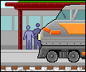  The supermarket.  The police station.  The restaurant.  The bank.  The cinema.  The park.  The park is between the bank and the restaurant.  The cinema is next to the bank.  Pupils use new words in sentences using some pictures presented on the black board.  Teacher asks pupils about their town and makes them making a sentence using the new words. | 25mn
Practice | 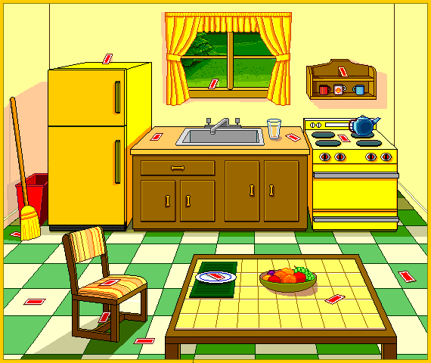  Teacher invites pupils to open their books at page185  Teacher reads the text.  Pupils follow on their books.  Then pupils read the text to.  Teacher plays the cassette twice. Pupils listen and follow on their books. ( the song : where is the zoo?)  Pupils repeat.  Teacher asks pupils to read then do the activities on page 186/187/188  Then check and correct  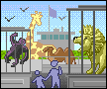 | 25mn

